[E103]_[E104] High pressure inlet valve

Unscrew the strain relief lock nut.

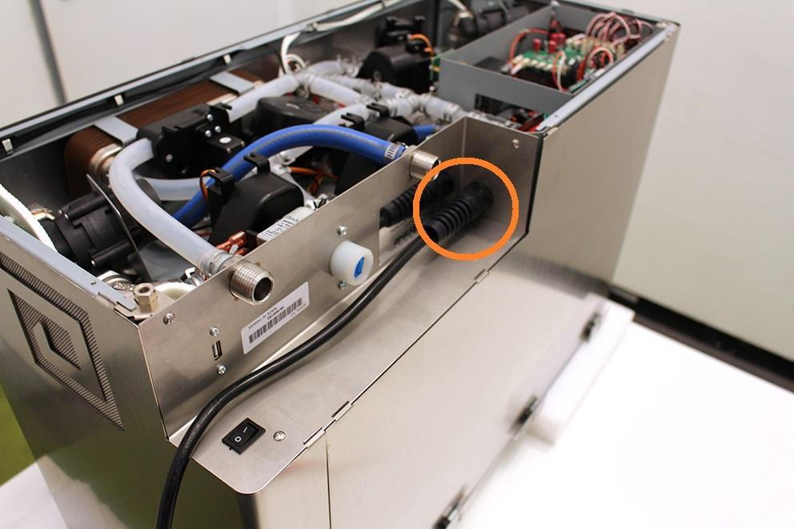

Remove the wort outlet hose clamp, pull off the wort outlet silicone tube and unscrew the indicated screws.

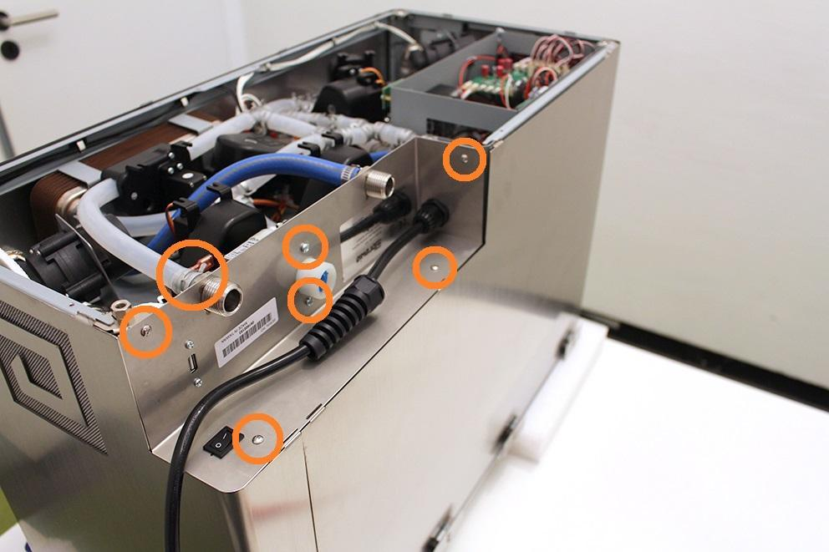

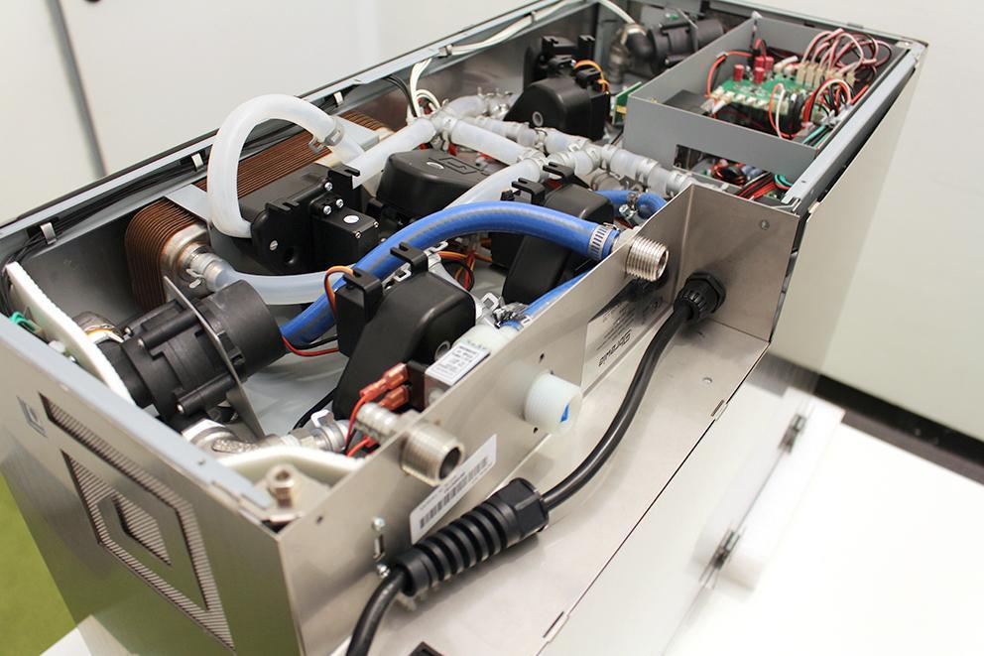

Remove the heat insulator.

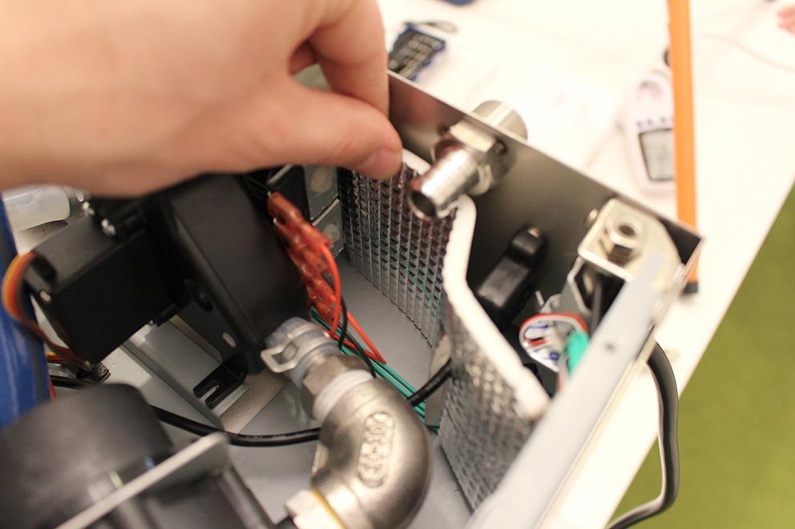

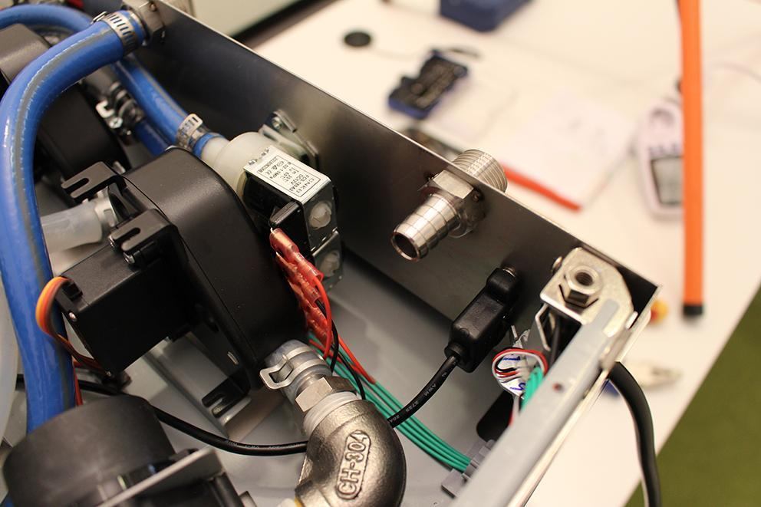

Remove the USB plug. Make sure that the washers don’t fall under the assembling plate. Use magnet for this step.

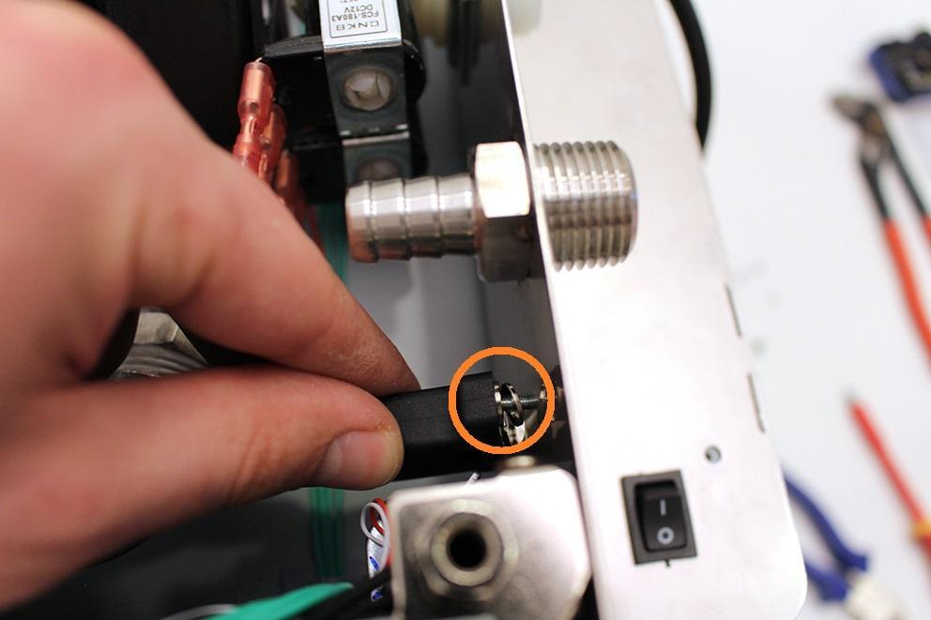

Loosen the indicated hose clamp and remove the high pressure hose from the fitting.

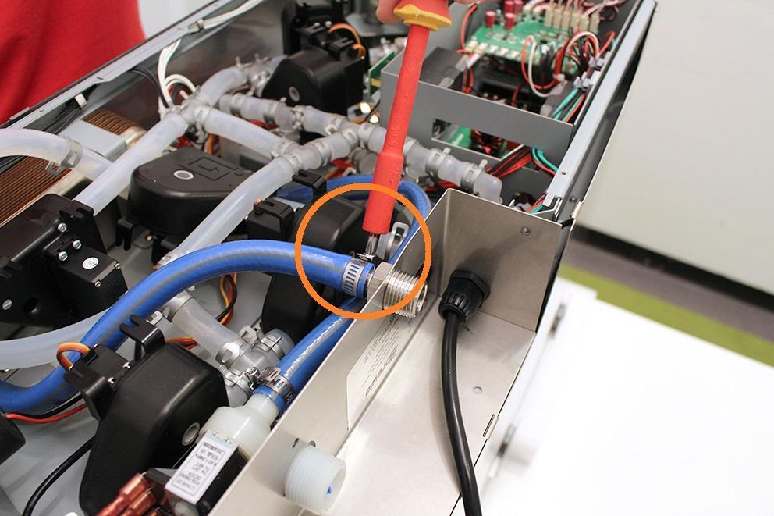

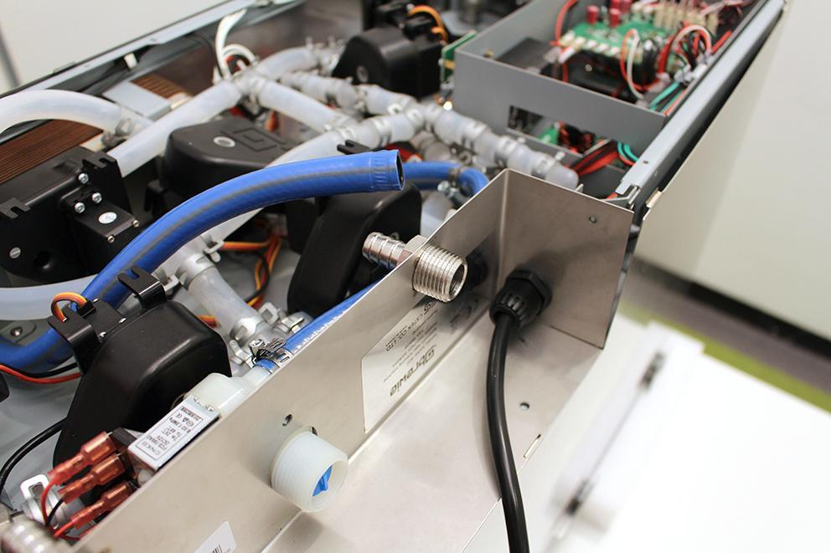

Pull up the sheetmetal part carefully and unplug the indicated plugs with a screwdriver.

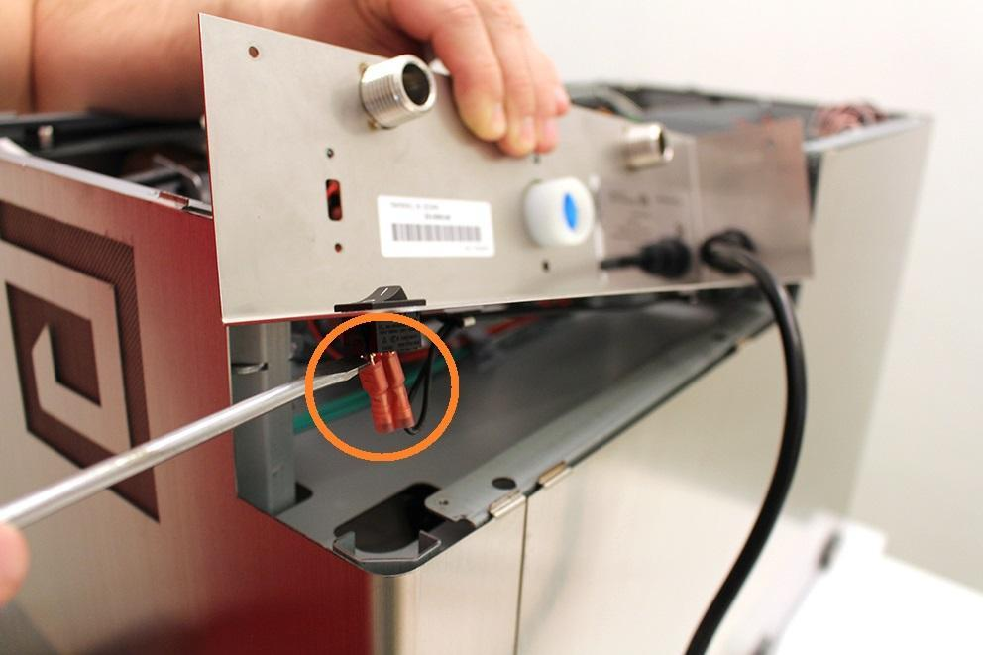

Remove the cables from the cable clips.

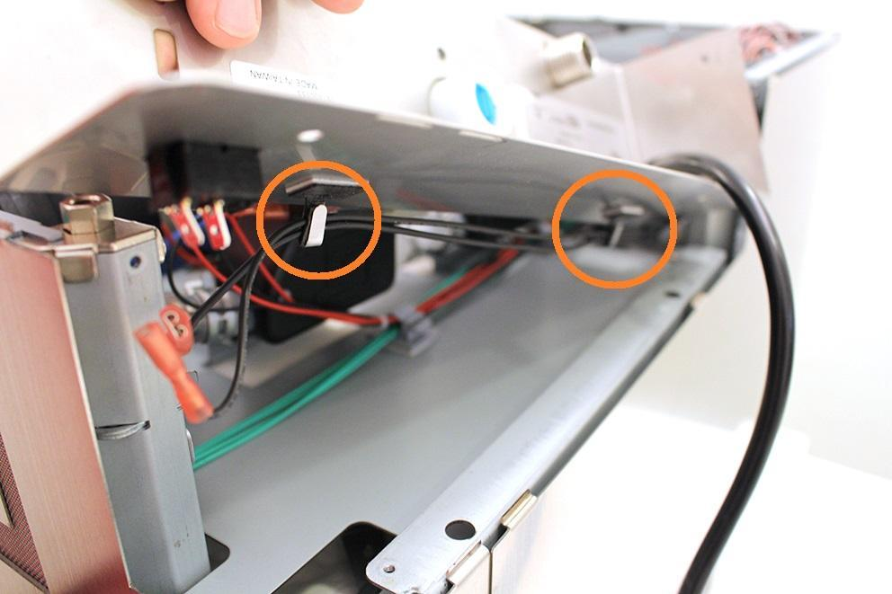

Pull off the high pressure valve from the sheetmetal. Pull off the sheetmetal on the power cable and put it on a safe place.

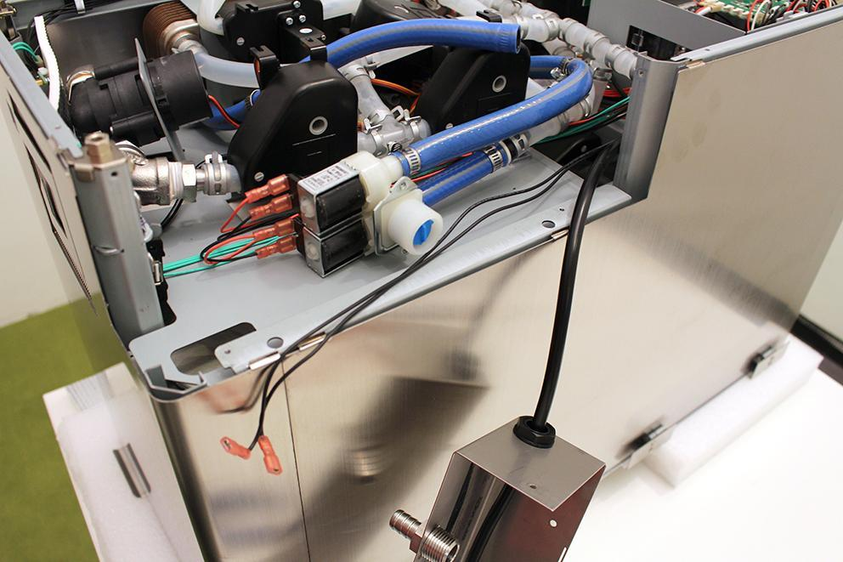

Loosen the indicated hose clamps and remove it. Remove the high pressure tubes. Remove the valve plugs. Now you can change the high pressure valve.

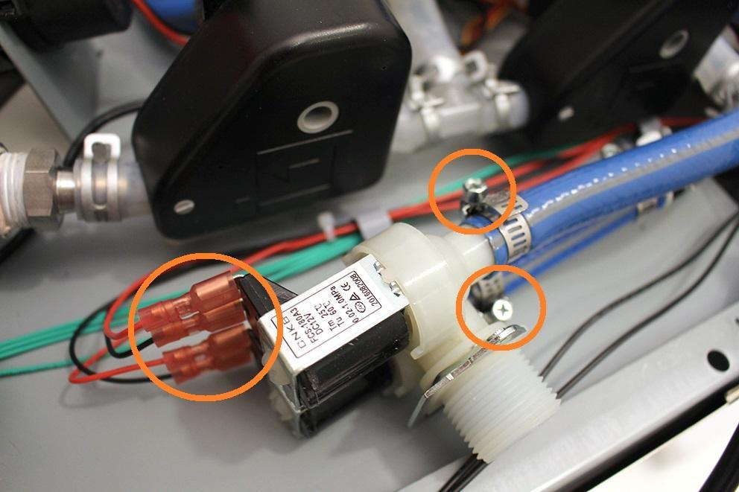

Reassemble consists of the same steps in reverse.

Make sure that the wort outlet hose clamp is in the proper angle. Otherwise you cannot reassemble the bottom sheetmetal.

